**Note: Since AWS Code Commit is no longer supported for new users or organizations, I was advised to transition to GitHub, which I have now done.**

Created a repository, added a file, and then committed it to the local repository.

Creating a repository in the GitHub

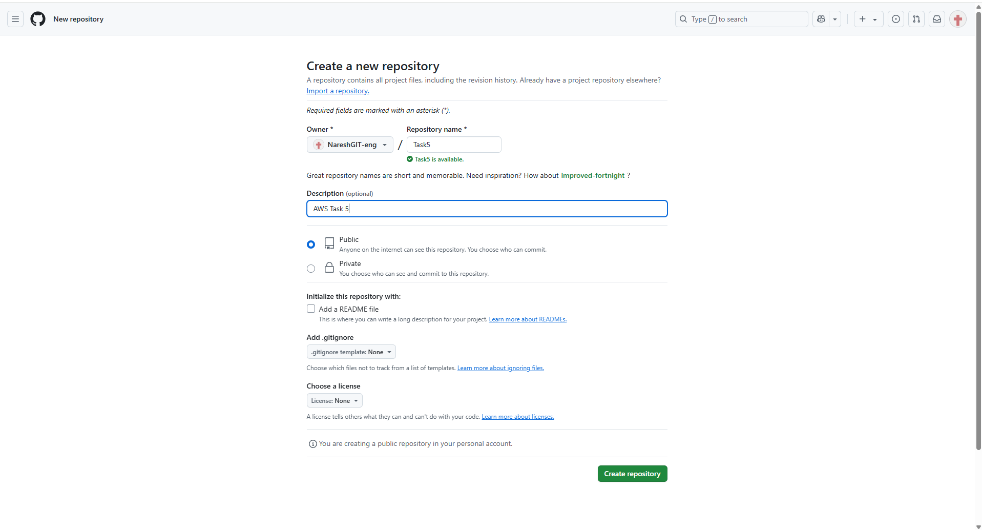

Pushing the file from local to GitHub

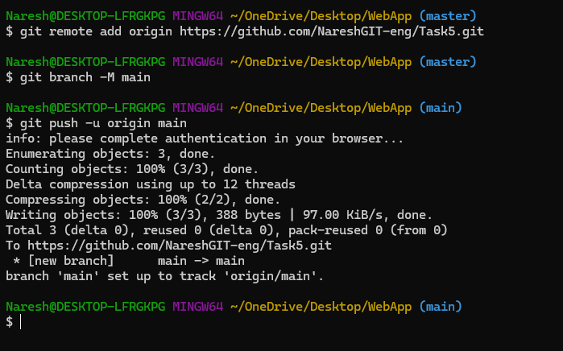

Code build



